TO WHOMEVER IT MAY CONCERN

I MR. RIJWAN ALI do hereby declare that I will make my car
UP32ZN1290 (number on plate) available on rent to AORVIS Dynamic Pvt. Ltd. for the Tender No:
141/ET/MECL/MM/CONT/CGH/03, dated 21.04.2026 - Handling of Geophysical Equipment and other services during Ground Gravity and Magnetic Survey under NGPM.

The RC of the car is attached.
The car has Taxi Permit.

Car Make: TOYOTA

Car Model: INNOVA CRYSTA GX (MT)

Name: MR. RIJWAN ALI
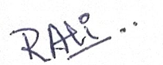

Signature:

Place: ODISHA
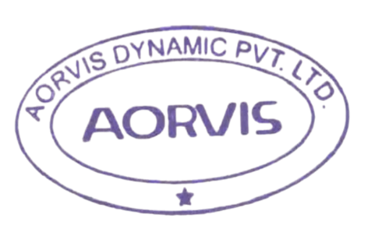
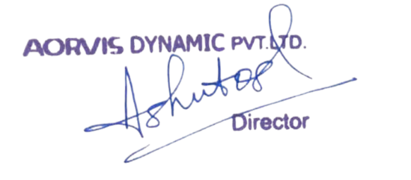
Date: 30/06/2026

TO WHOMEVER IT MAY CONCERN

I MR. MOHD NASEER ALI do hereby declare that I will make my car
UP32XN8153 (number on plate) available on rent to AORVIS Dynamic Pvt. Ltd. for the Tender No:
141/ET/MECL/MM/CONT/CGH/03, dated 13.04.2026 - Handling of Geophysical Equipment and other services during Ground Gravity and Magnetic Survey under NGPM.

The RC of the car is attached.
The car has Taxi Permit.

Car Make: TOYOTA

Car Model: INNOVA CRYSTA GX (MT)

Name: MR. MOHD NASEER ALI

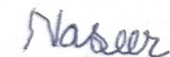
Signature:

Place: ODISHA
Date: 30/06/2026

TO WHOMEVER IT MAY CONCERN

I ASLAM do hereby declare that I will make my car
UP32ZN9667 (number on plate) available on rent to AORVIS Dynamic Pvt. Ltd. for the Tender No:
141/ET/MECL/MM/CONT/CGH/03, dated 13.04.2026 - Handling of Geophysical Equipment and other services during Ground Gravity and Magnetic Survey under NGPM.

The RC of the car is attached.
The car has Taxi permit.

Car Make: TOYOTA

Car Model: INNOVA CRYSTA 2.4G

Name: ASLAM

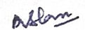
Signature:

Place: ODISHA
Date: 30/06/2026

TO WHOMEVER IT MAY CONCERN

I MR. MOHD ARIF do hereby declare that I will make my car
UP32QT8823 (number on plate) available on rent to AORVIS Dynamic Pvt. Ltd. for the Tender No:
144/ET/MECL/MM/CONT/CGH/04, dated 20.06.2026 - Handling of Geophysical Equipment and other services during Ground Gravity and Magnetic Survey under NGPM.

The RC of the car is attached.
The car has Taxi Permit.

Car Make: KIA

Car Model: CARENS D1.5 6MT PREMIUM

Name: MR. MOHD ARIF

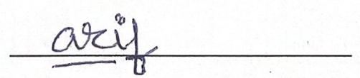
Signature:

Place: ODISHA

Date: 30/06/2026

